OPC

Please follow this guide to install OPC

Steps:
1. Install PecOPC Setup.exe.
2. Copy the PecsOPCServer.exe into the Common folder.
3. Copy the PecsOPCServer.lang into the Common\Language folder (English version).

Notes: Due to business development, since April 10th, 2017, Ceiec Electric Technology Inc. has been renamed to CET Electric Technology Inc., however, the products (including hardware and software) that were manufactured before this date may still involve old name or logo.
Install PecOPC

- Double-click the PecOPC Setup.exe to begin the installation.

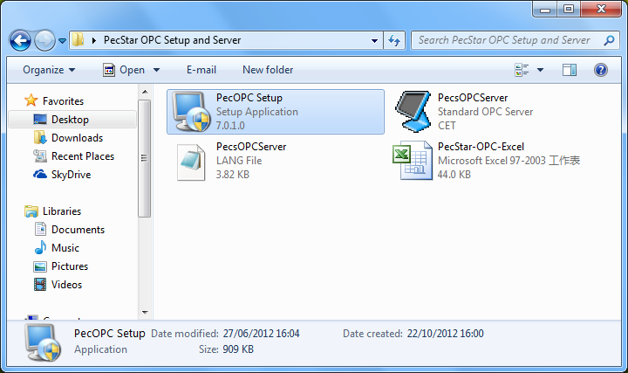

- Click Next.

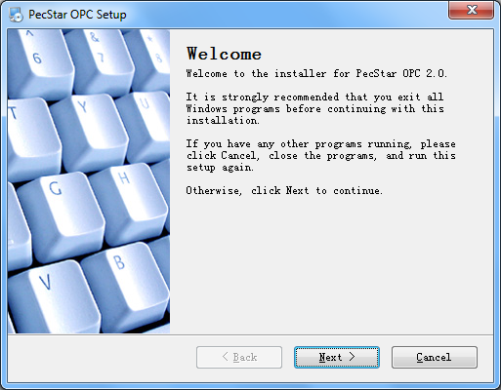
- Read the License Agreement. If you agree, click “I agree to the terms of this license agreement” and click Next.
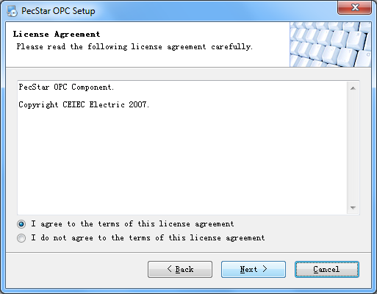
Notes: CEIEC Electric Technology or Ceiec Electric Technology was changed to CET Electric since May 1, 2017.
- Input your Name and Company, click Next.
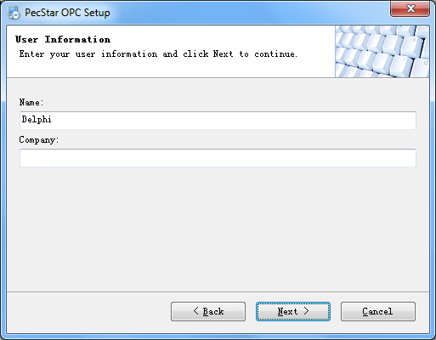

- Select an Installation Path and click Next.
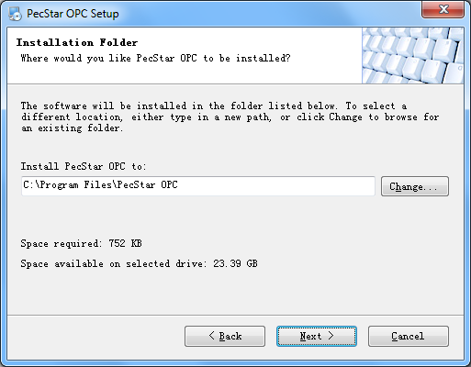
- Here you can type in the Shortcut Folder’s name. And you can determine the shortcuts are available for all users or just for the current user only.
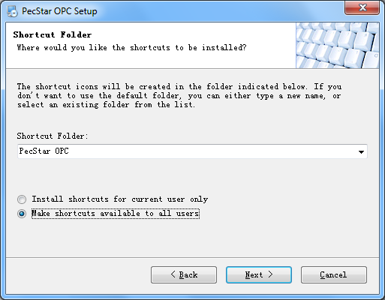

- Confirm the information and click Next to begin the Installation.
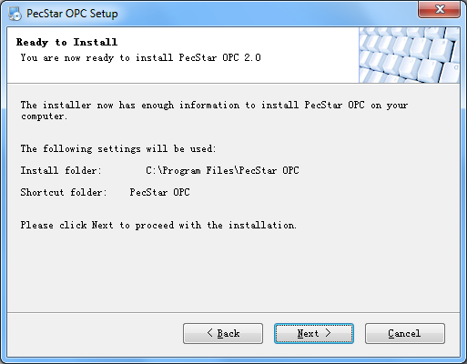

- When the Installation finished, Click Finish to exit the application.
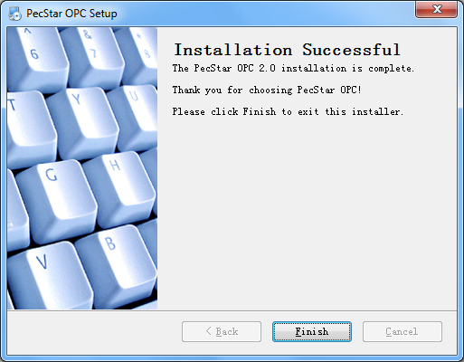

Copy PecsOPCServer.exe and PecsOPCServer.lang
Now we can begin the next steps:
- Come back to this folder.
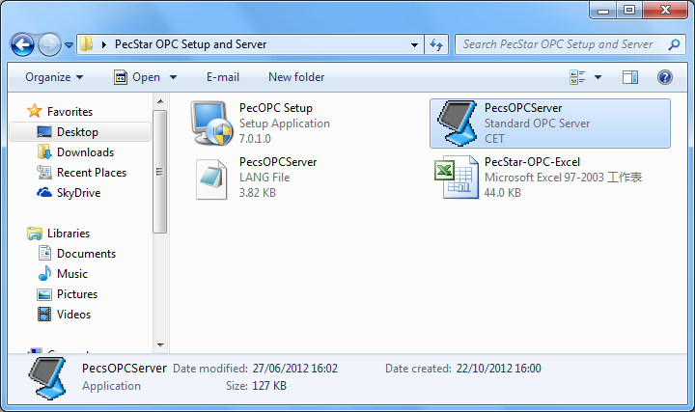

- Copy PecsOPCServer.exe to the Common folder. For example, if you install PecStar in D:\CET, then please copy this file to D:\CET\Common.
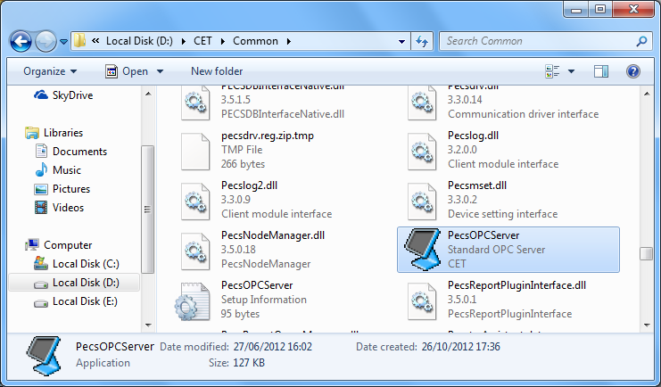

- Copy PecsOPCServer.lang to the D:\CET\Common\language folder.
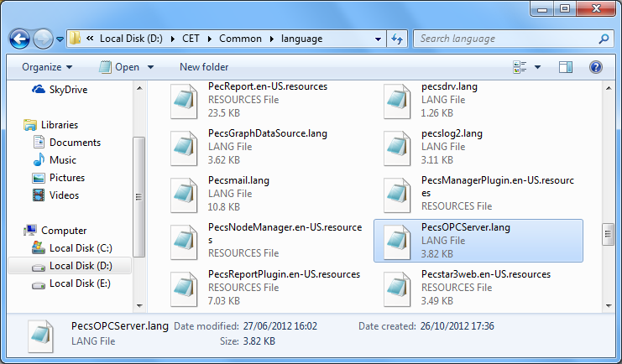

- Now all the installation steps are finished.

Configure PecsOPC Server
- Double-click PecsOPCServer.exe.

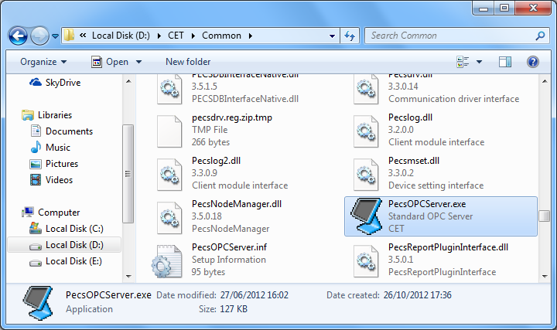

- Click Config.

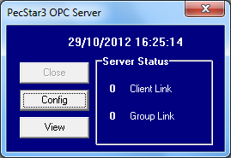

- Input the user name and password. Click OK.

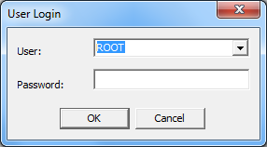

- Click Add to add the parameters.

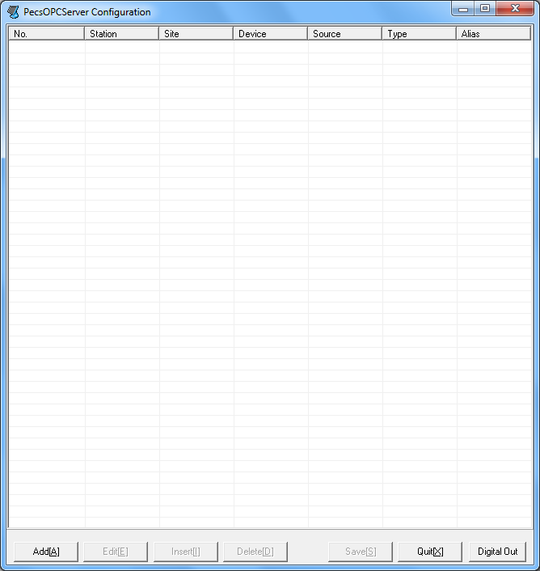
- Similar to PecConfig, you can select and add the parameters.

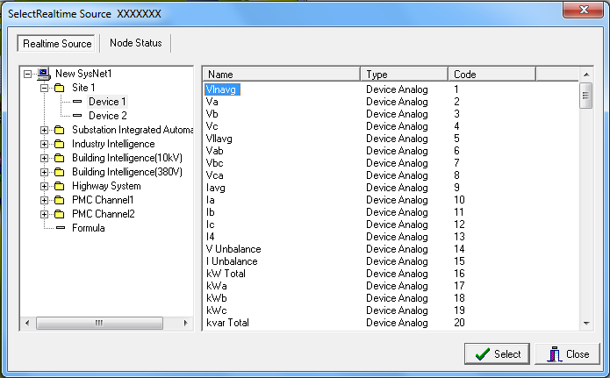

- Click the Save button to save the configuration. After you add all the Parameters, Click the Quit button.

- Click the View button. The Value should be the same with Front.exe.

